1. Manual connection 1.

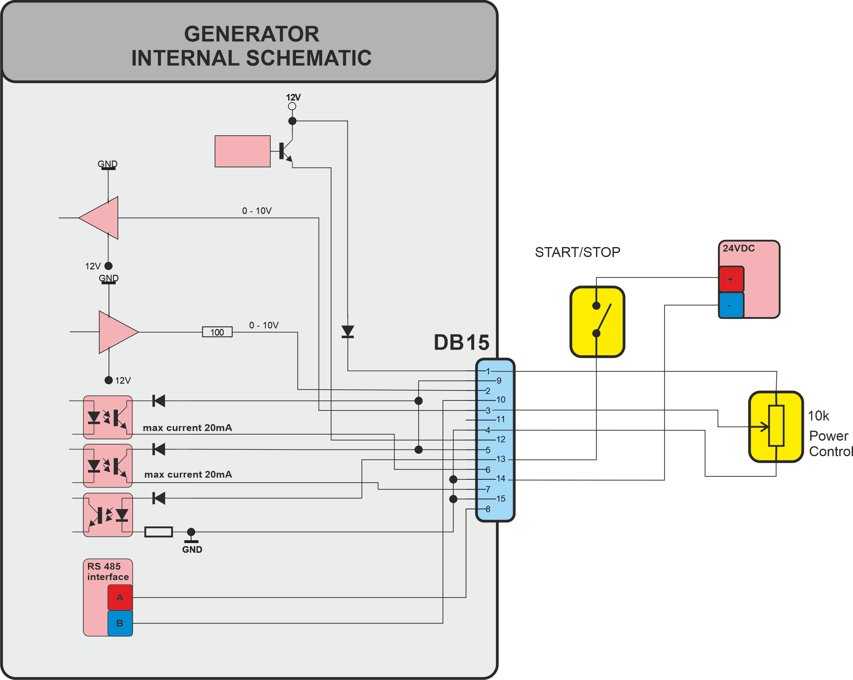

1. Manual connection 2.



1. Connection to PLC.

